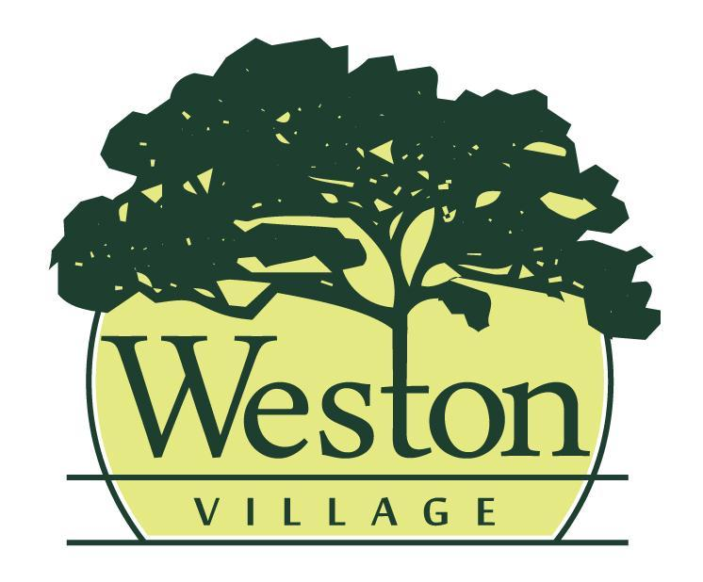
Council Meeting Agenda
6/15/26, 6:00pm

Mayor:
Rick Easterwood

Council:
Craig Warner, Travis Ackerman, Erica Rupp, Ashley Patel, Jessica Susor, Brittney Klockowski

- Pledge of Allegiance & Roll Call
- Presentation of Agenda and approval of any changes to the agenda.
- Minutes from the previous council meeting (6/1/26) will be read and accepted as written, any additions or corrections will be noted.
- Old Business
- Second Reading Resolution Authorizing the Sale of Village Property by Internet Auction
- Reports
- Mayor
- Fiscal Officer/Clerk
- Administrator/Maintenance
- Code Enforcement/Zoning
- Committee Report(s)
  - Cemetery Board 6/4
  - Administrative Process from 6/8
  - Tree Commission from 6/9
- Upcoming Meetings: Community Development 6/16 at 5:30PM; Public Safety 6/22 at 6PM; Public Works 6/23 at 6PM
- New Business

- Approval of Expenditures
- Council will review bills paid and warrants to be issued
- May Bank Reconciliation
- Miscellaneous Business
- Citizens & Visitors will have the opportunity to be heard, limited to 3 minutes each.
- Adjourn

