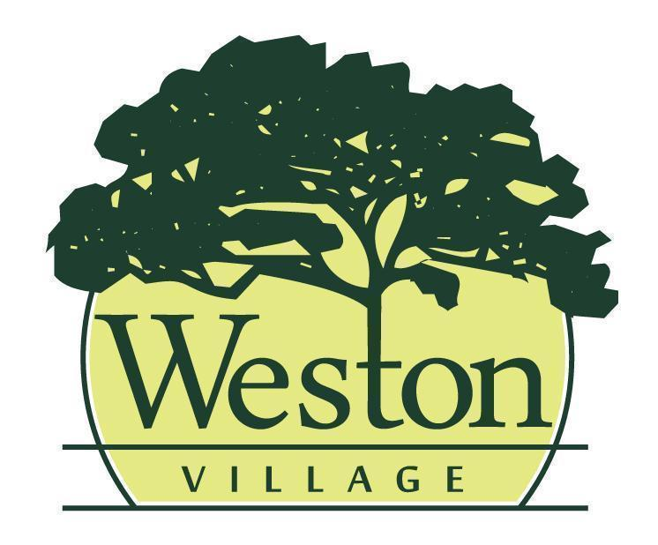

Council Meeting Agenda
10/19/26 @ 6:00PM

Mayor: Rick Easterwood
Council: Craig Warner, Travis Ackerman, Erica Rupp, Ashley Patel, Jessica Susor, Brittney Klockowski

- Pledge of Allegiance & Roll Call
- Presentation of Agenda and approval of any changes to the agenda.
- Minutes from the previous council meeting (10/5/26) will be read and accepted as written, any additions or corrections will be noted.
- Public Presentation:
- Old Business:
  - Final Reading: Ordinance amending the zoning ordinance of the village of Weston
- Reports
  - Mayor
  - Fiscal Officer/Clerk
  - Administrator/Maintenance
  - Code Enforcement/Zoning
- Committee Report(s)
  - Administrative Process 10/12
  - Tree Commission 10/13
- Upcoming Meetings: Community Development 10/20 @5:30 PM; Public Safety 10/26 @ 6PM; Public Works 10/27 @ 6PM; Cemetery 11/5 @ 6:00 PM
- New Business
  - First Reading: 2027 Appropriation Ordinance
- Approval of Expenditures
  - Council will review bills paid and warrants to be issued
- Miscellaneous Business
- Citizens & Visitors will have the opportunity to be heard, limited to 3 minutes each.
- Adjourn

