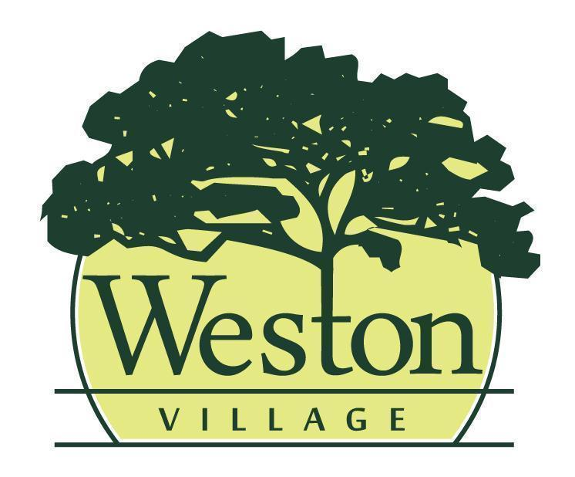

Council Meeting Agenda
8/17/26 @ 6:00PM

Mayor: Rick Easterwood
Council: Craig Warner, Travis Ackerman, Erica Rupp, Ashley Patel, Jessica Susor, Brittney Klockowski

- Pledge of Allegiance & Roll Call
- Presentation of Agenda and approval of any changes to the agenda.
- Minutes from the previous council meeting (8/3/26) will be read and accepted as written, any additions or corrections will be noted.
- Public Presentation: Bill Barnhart in attendance seeking nomination for NWWSD board
- Old Business
- Reports
  - Mayor
  - Fiscal Officer/Clerk
  - Administrator/Maintenance
  - Code Enforcement/Zoning
- Committee Report(s)
  - Cemetery 8/6 - CANCELED
  - Admin Process 8/10
  - Records Commission 8/10
  - Tree Commission 8/11
- Upcoming Meetings: Community Development 8/18 @ 5:30PM; Public Safety 8/24/27 @6PM; Public Works 8/25 @6PM; Cemetery Board 9/3 @ 6: 00PM
- New Business
  - Wood County Park District Grant / Emergency RES 2026-10 to Participate in WCPD Grant
  - Emergency ORD 2026-9, Amend Appropriations for John Deere Zero Turn
  - 1st Reading to Amend Wage Schedule
- Approval of Expenditures
  - Council will review bills paid and warrants to be issued
  - July Bank Reconciliation
- Miscellaneous Business
- Citizens & Visitors will have the opportunity to be heard, limited to 3 minutes each.
- Adjourn

