Council Meeting Agenda
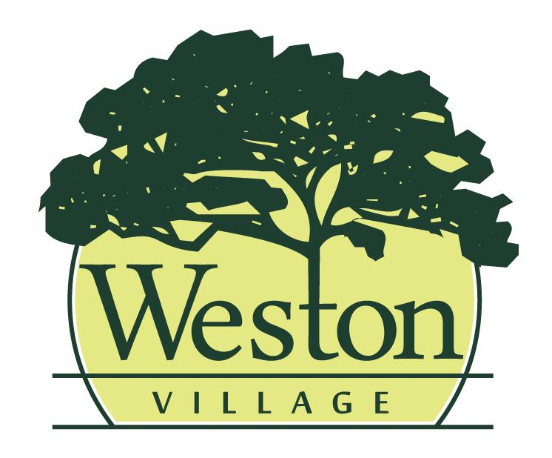
Council Meeting Agenda
5/18/26, 6:00pm

Mayor:
Rick Easterwood

Council:
Craig Warner, Travis Ackerman, Erica Rupp, Ashley Patel, Jessica Susor, Brittney Klockowski

- Pledge of Allegiance & Roll Call
- Presentation of Agenda and approval of any changes to the Agenda.
- Minutes from the previous council meeting (5/4/26) will be read and accepted as written, any additions or corrections will be noted.
- Old Business
- Second Reading ORD for Cybersecurity Policy
- Second Reading RES for Electric Supplier Agreement with Purchase Power (formerly Aspen Energy)
- 3rd Reading: ORD 2026-6 to Amend Appropriations for WCSO rate increase
- Reports
- Mayor
- Fiscal Officer/Clerk
- Administrator/Maintenance
- Code Enforcement/Zoning
- Committee Report(s)
  - Cemetery Board Meeting from 5/7
  - Administrative Process from 5/11
  - Tree Commission Meeting from 5/12
- Upcoming Meetings: Community Development 5/19 at 5:30PM, Public Works 5/26 at 6PM, Safety 5/27 at 6PM
- New Business
- Emergency: RES 2026-4 for Mutual Aid Agreement
- Approval of Expenditures
- Council will review bills paid and warrants to be issued
- Miscellaneous Business

- Citizens & Visitors will have the opportunity to be heard, limited to 3 minutes each.
- Adjourn

