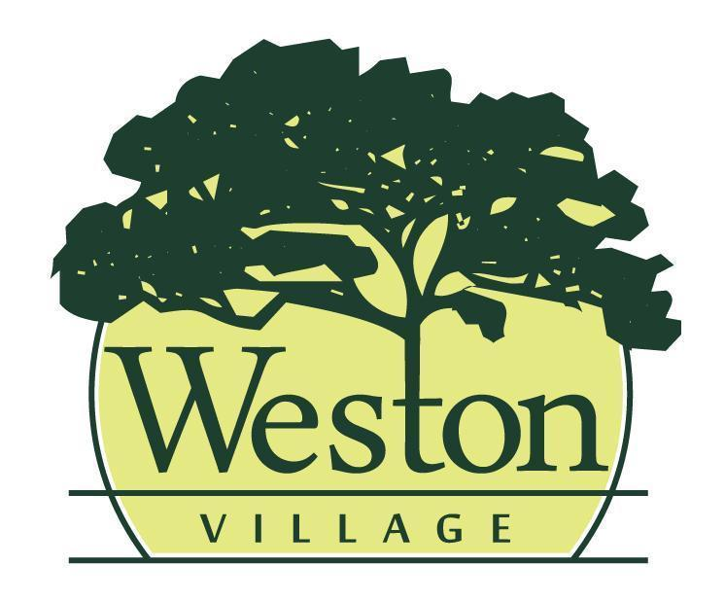

Council Meeting Agenda
7/20/26, 6:00PM

Mayor: Rick Easterwood
Council: Craig Warner, Travis Ackerman, Erica Rupp, Ashley Patel, Jessica Susor, Brittney Klockowski

- Pledge of Allegiance & Roll Call
- Presentation of Agenda and approval of any changes to the agenda.
- Minutes from the previous council meeting (7/6/26) will be read and accepted as written, any additions or corrections will be noted.
- Old Business
- Final Reading RES 2026-7: Resolution to create the Village of Weston Parks & Recreation advisory commission
- Reports
- Mayor
- Fiscal Officer/Clerk
- Administrator/Maintenance
- Code Enforcement/Zoning
- Committee Report(s)
- Administrative Process 7/13
- Tree Commission 7/14

- Upcoming Meetings: Cemetery Board 7/21 @ 9AM; Community Development 7/21 @ 5:30PM; Public Safety 7/27 @6PM; Public Works 7/28 @6PM
- New Business

- Approval of Expenditures
- Council will review bills paid and warrants to be issued
- June Bank Reconciliation
- Miscellaneous Business
- Citizens & Visitors will have the opportunity to be heard, limited to 3 minutes each.
- Adjourn

